**Practical -3**

Implementing Image, Table and List in HTML

Q1 Write a script which display image using all its attributes [ scr, align width, height and alt]

***HTML CODE:-***

<!DOCTYPE html>

<html lang="en">

<head>

<title>Document</title>

</head>

<body>

<img

src="images/k.jpg"

width="150px"

height="150px"

alt="bird"

align="right"

/>

</body>

</html>

***OUTPUT:-***

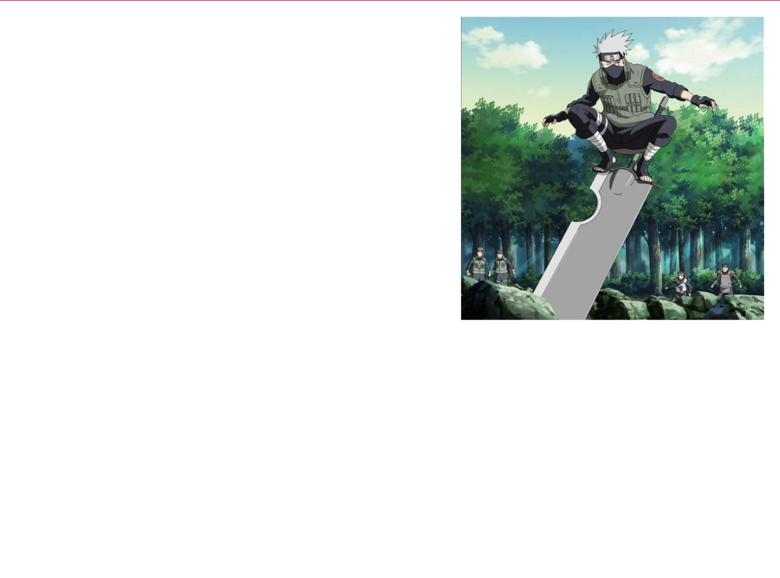

Q2. Write a script which display table using all its attributes [ tr, td, th, caption]

***HTML Code :-***

<!DOCTYPE html>

<html lang="en">

<head>

<title>Document</title>

</head>

<body>

<table border="2px">

<caption>html table</caption>

<tr>

<th>heading1</th>

<th>heading2</th>

</tr>

<tr>

<td>data1</td>

<td>data2</td>

</tr>

</table>

</body>

</html>

***OUTPUT :-***

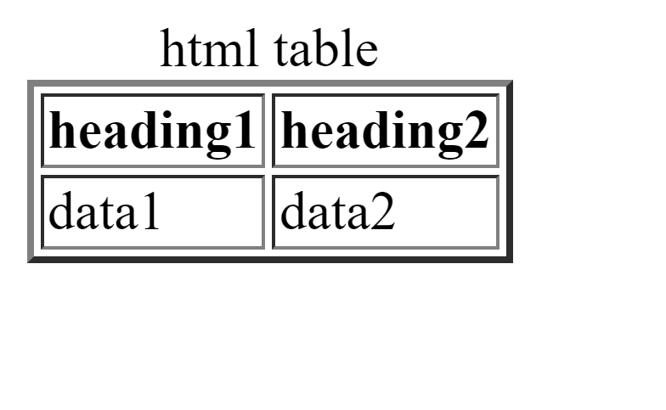

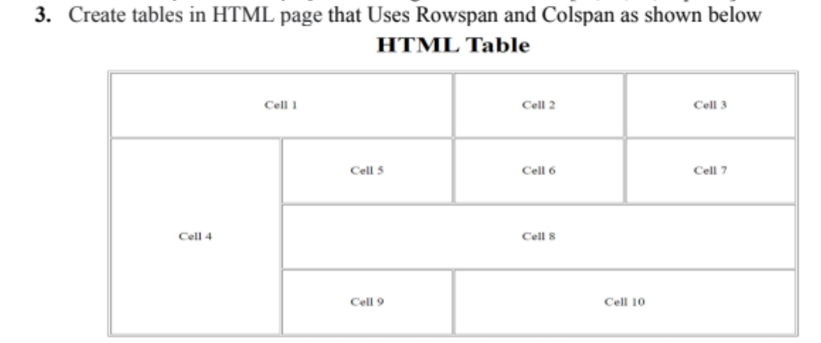

***HTML Code :-***

<!DOCTYPE html>

<html lang="en">

<head>

<title>Document</title>

</head>

<body>

<table border="1px" cellpadding="10" >

<caption><h1>HTML table</h1></caption>

<tr>

<td colspan="2">cell 1</td>

<td>cell 2</td>

<td>cell 3</td>

</tr>

<tr>

<td rowspan="3">cell 4</td>

<td>cell 5</td>

<td>cell 6</td>

<td>cell 7</td>

</tr>

<tr>

<td colspan="3"> cell 5</td>

</tr>

<tr>

<td>cell 9</td>

<td colspan="2"> cell 10</td>

</tr>

</table>

</body>

</html>

***OUTPUT :-***

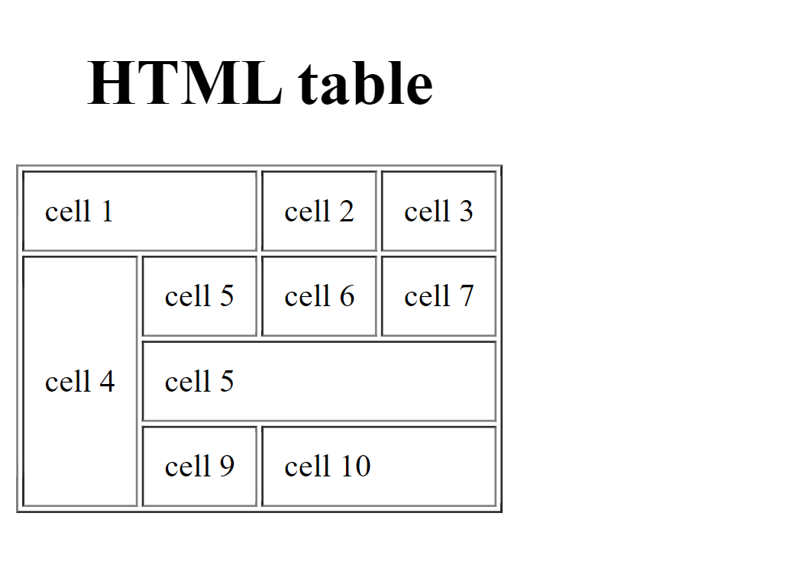

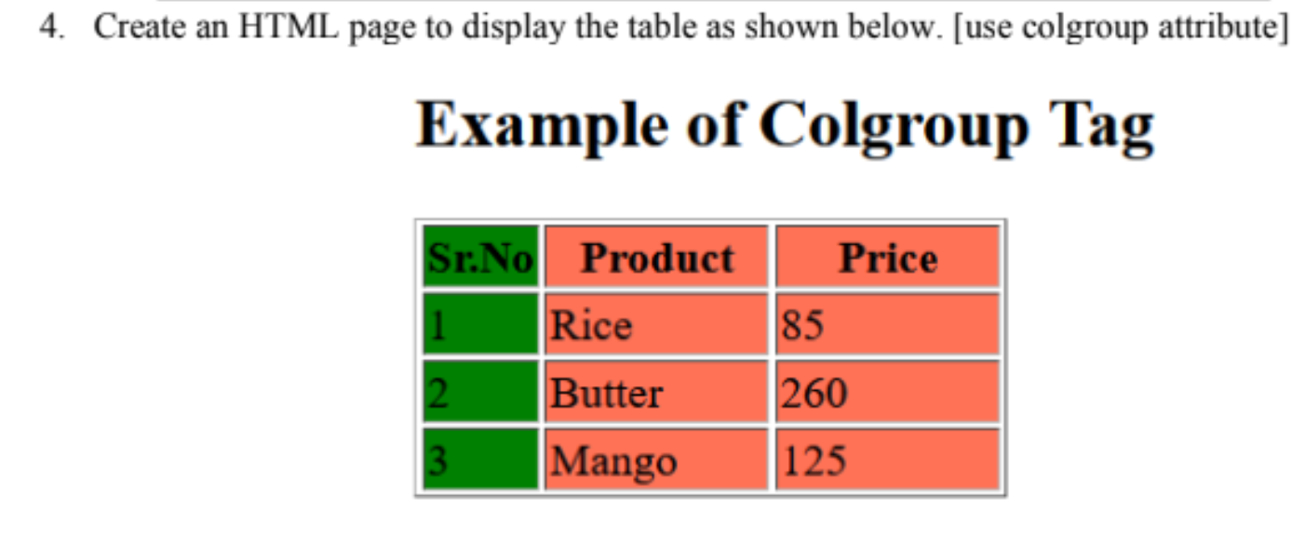

***HTML Code :-***

<html>

<head>

<title>Document</title>

</head>

<body>

<h1>Example Of Colgroup</h1>

<table border="1" cellpadding="10px">

<colgroup>

<col style="background-color:green">

<col span="2" style="background-color:rgb(232, 102, 16)">

</colgroup>

<tr>

<th>sr.No</th>

<th>product</th>

<th>Price</th>

</tr>

<tr>

<td>1</td>

<td>rice</td>

<td>85</td>

</tr>

<tr>

<td>2</td>

<td>Butter</td>

<td>260</td>

</tr>

<tr>

<td>3</td>

<td>Mango</td>

<td>125</td>

</tr>

</table>

</body>

</html>

***OUTPUT :-***

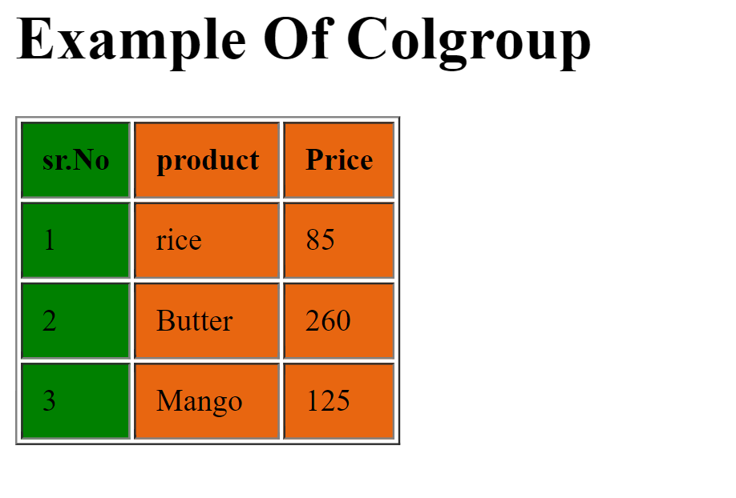

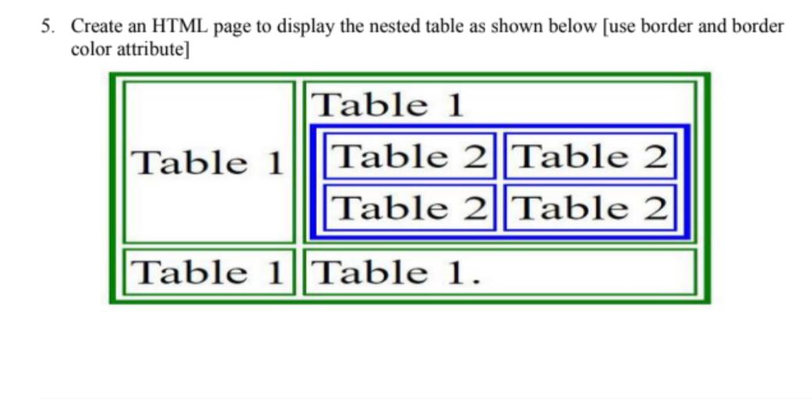

***HTML Code :-***

<!DOCTYPE html>

<html lang="en">

<head>

<title>Document</title>

</head>

<body>

<table border="2" style="border: 1px solid green">

<tr>

<td>Table 1</td>

<td>

Table 1

<table border="2" style="border: 1px solid blue">

<tr>

<td>table 2</td>

<td>table 2</td>

</tr>

<tr>

<td>table 2</td>

<td>table 2</td>

</tr>

</table>

</td>

</tr>

<tr>

<td>Table 1</td>

<td>Table 1</td>

</tr>

</table>

</body>

</html>

***OUTPUT :-***

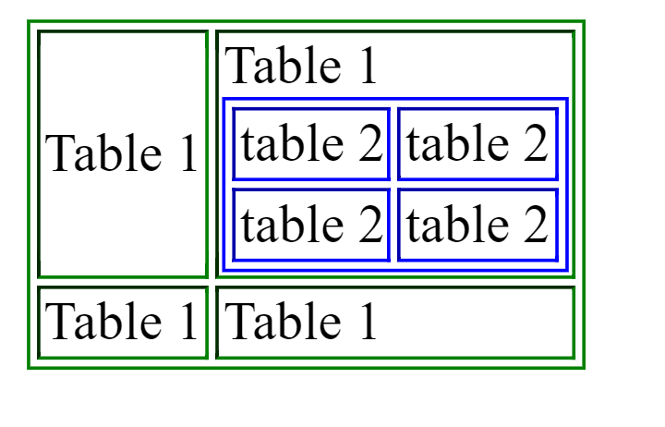

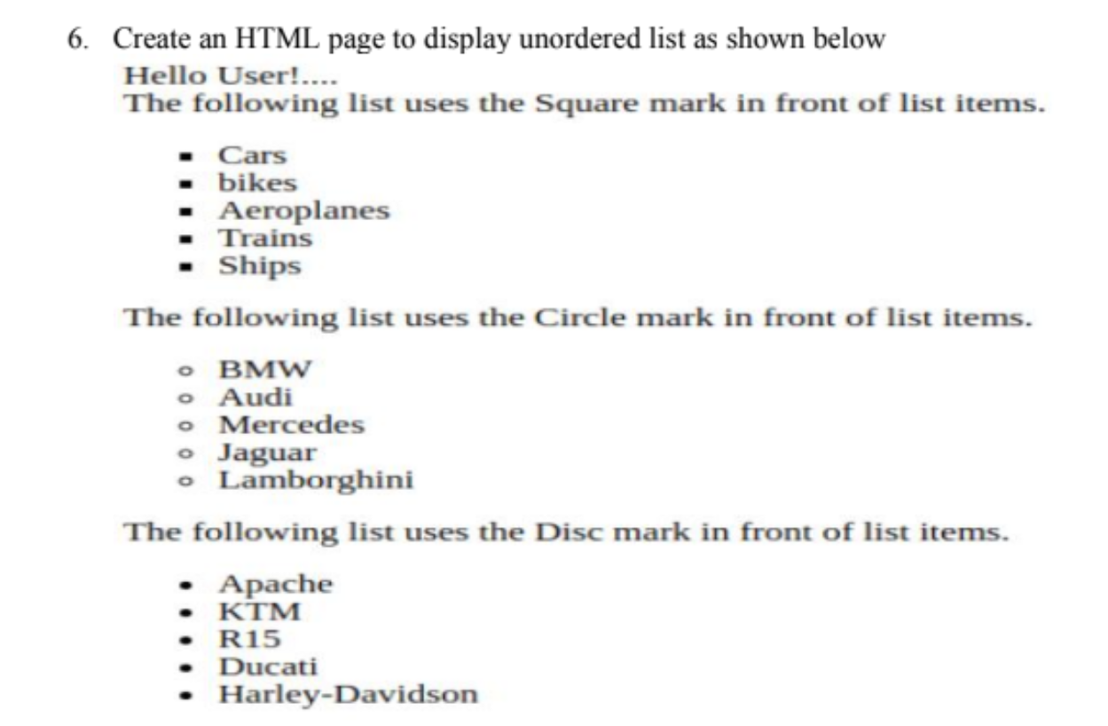

***HTML Code :-***

<!DOCTYPE html>

<html lang="en">

<head>

<title>Document</title>

</head>

<body>

<p>

Hello User !...<br>

The Following list uses squre marks in front of list items

</p>

<ul type="squre">

<li>cars</li>

<li>bikes</li>

<li>Aeroplanes</li>

<li>Trains</li>

<li>Ships</li>

</ul>

<p>

Following list uses the circle marks in front of list items

</p>

<ul type="circle">

<li>BMW</li>

<li>Audi</li>

<li>Mercedes</li>

<li>Jaguar</li>

<li>Lamborghini</li>

</ul>

<p>the following list uses the disc marks in front of list items </p>

<ul type="disc">

<li>Apache</li>

<li>KTM</li>

<li>R15</li>

<li>Ducati</li>

<li>Harley-Davidson</li>

</ul>

</body>

</html>

***OUTPUT :-***

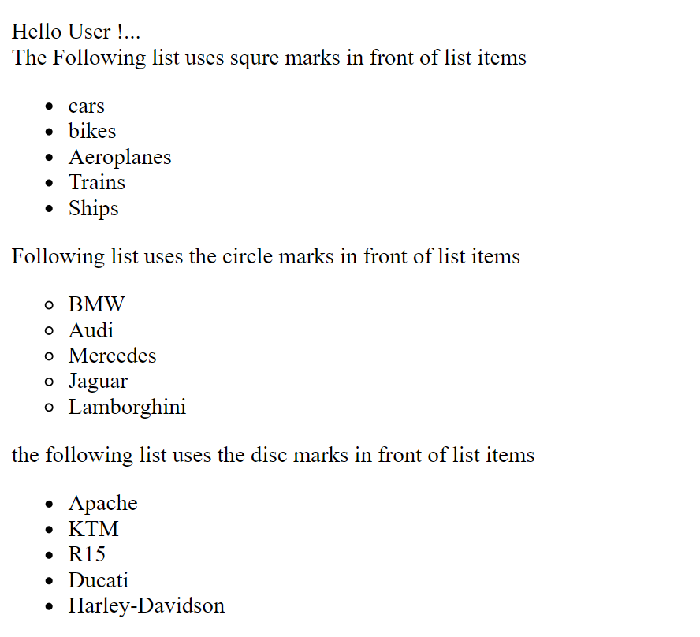

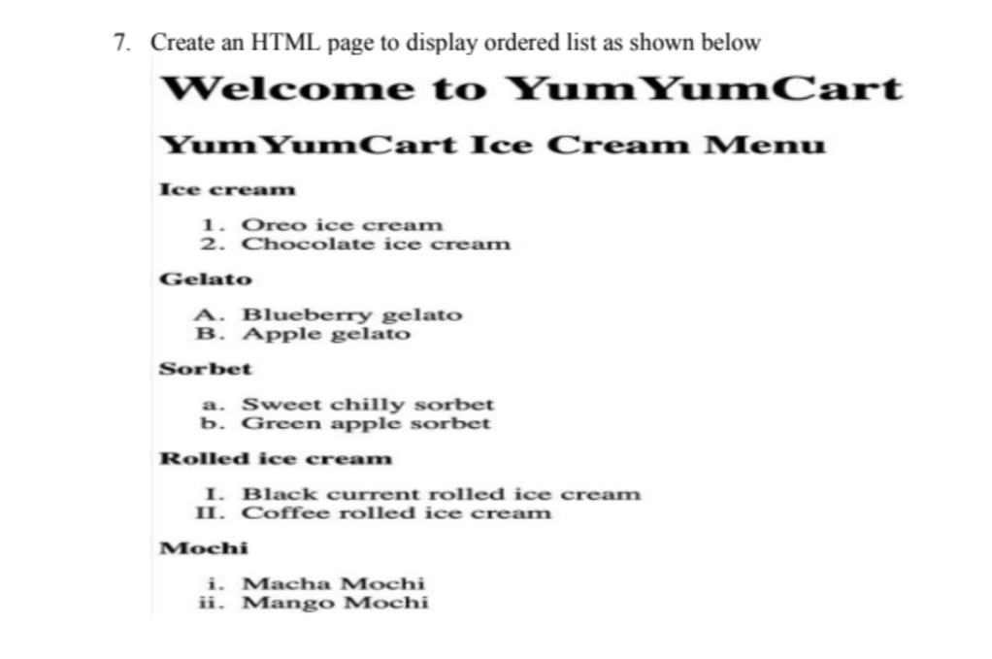

***HTML Code :-***

<!DOCTYPE html>

<html lang="en">

<head>

<title>Document</title>

</head>

<body>

<h1>Welcome to YumYum Cart</h1>

<h2>YumYum Cart Ice Cream Menu</h2>

<h3>Ice cream</h3>

<ol type="1">

<li>Oreo Icecream</li>

<li>chocolate Icecream</li>

</ol>

<h3>Gelato</h3>

<ol type="A">

<li>Bluebarry Gelato</li>

<li>Apple Gelato</li>

</ol>

<h3>Sorbet</h3>

<ol type="a">

<li>Sweet chilly Sorbet</li>

<li>Green Apple Sorbet</li>

</ol>

<h3>Rolled Ice Cream</h3>

<ol type="I">

<li>Black Current Rolled Ice Cream</li>

<li>Coffee Rolled Ice Cream</li>

</ol>

<h3>Mochi</h3>

<ol type="i">

<li>Macha Mochi</li>

<li>Mango Mochi</li>

</ol>

</body>

</html>

***OUTPUT :-***

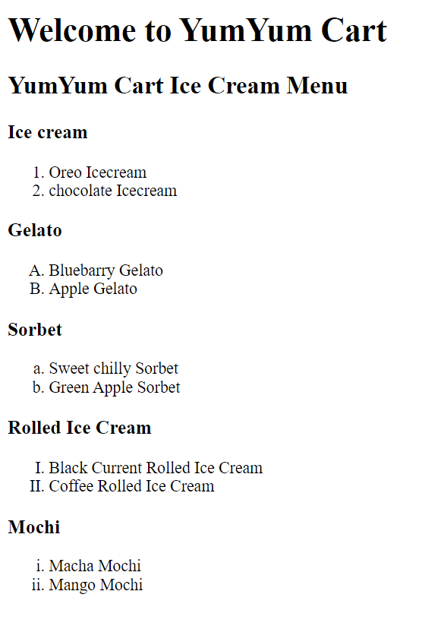

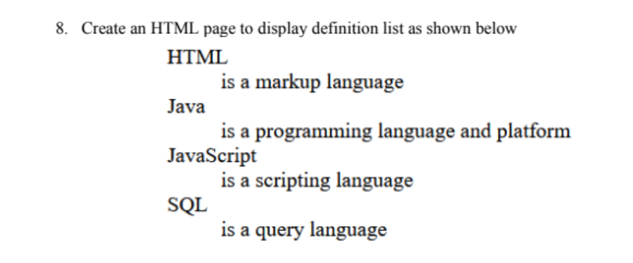

***HTML Code :-***

<html>

<head>

<title>Document</title>

</head>

<body>

<dl>

<dt>HTML</dt>

<dd>Is a markup language</dd>

<dt>Java</dt>

<dd>Is a programming language and platform</dd>

<dt>JavaScript</dt>

<dd>Is a Scripting language</dd>

<dt>SQL</dt>

<dd>Is a querry language</dd>

</dl>

</body>

</html>

***OUTPUT :-***

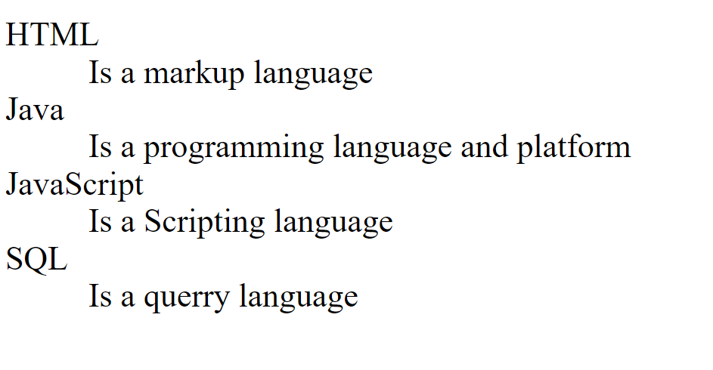

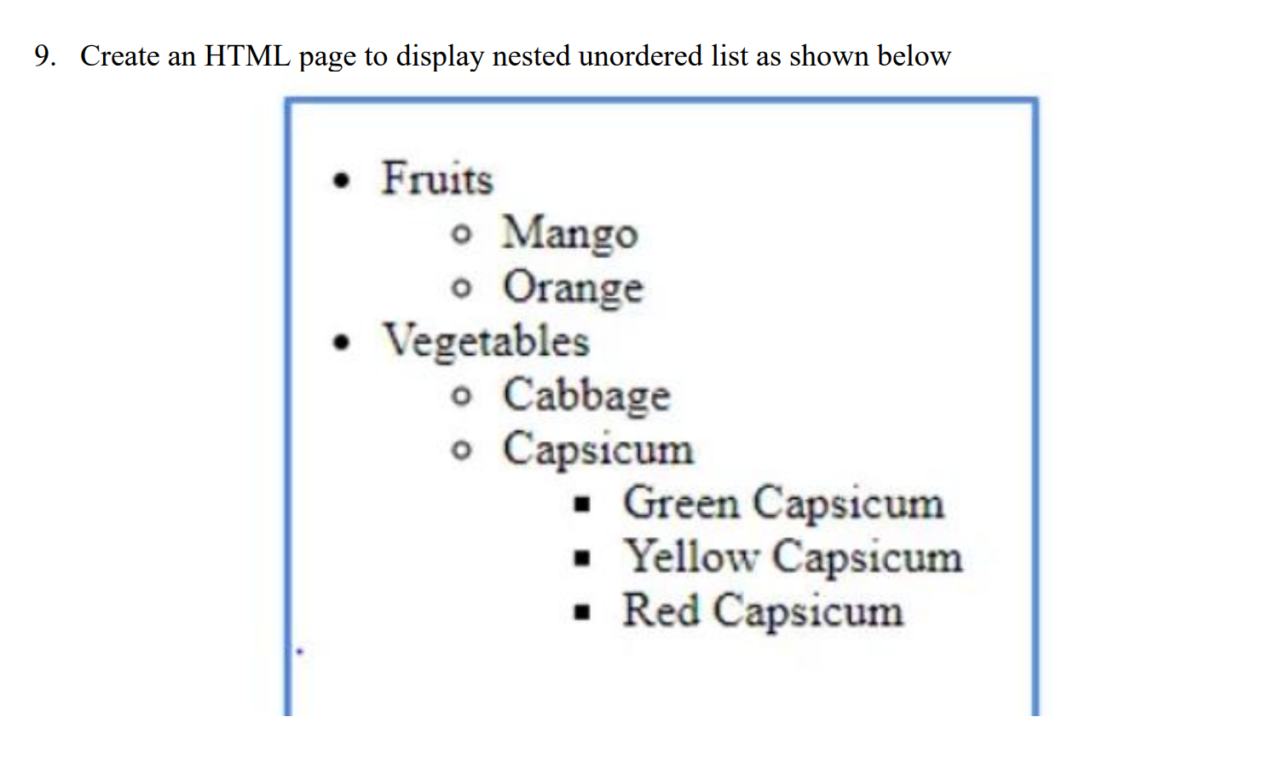

**HTML Code**

<!DOCTYPE html>

<html lang="en">

<head>

<title>Table </title>

</head>

<body>

<ul type="disc" style="border: 2px solid blue; width: 230px;">

<li>Fruits

<ul type="circle">

<li>Mango</li>

<li>Orange</li>

</ul>

</li>

<li>Vegetables

<ul type="circle">

<li>Cabbage</li>

<li>Capsicum

<ul type="square">

<li>Green Capsicum</li>

<li>Yellow Capsicum</li>

<li>Red Capsicum</li>

</ul>

</li>

</ul>

</li>

</ul>

</body>

</html>

***Output***

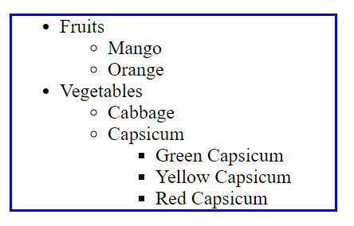

**HTML Code**

<!DOCTYPE html>

<html lang="en">

<head>

<title>Rowspan & Colspan </title>

</head>

<body>

<ol type="1">

<li><u>Unordered Lists</u></li>

<li><u>Ordered Lists</u>

<ol type="1">

<li><u>Changing Numbering</u>

<ol type="1">

<li>1.1.1 <u>Creating a Countdown List</u></li>

<li>1.1.2 <u>Starting a List on a Specific Number</u></li>

<li>1.1.3 <u>Changing the Numbering Style</u></li>

</ol>

</li>

</ol>

</li>

<li><u>Description Lists</u></li>

<li><u>Nested Lists</u></li>

<li>

Using Lists for Menus

<ol type="1">

<li>Menus</li>

<li>Lists</li>

</ol>

</li>

<li><u>Styling Lists</u></li>

<li><u>Closing Thoughts</u></li>

</ol></body>

</html>

***Output***

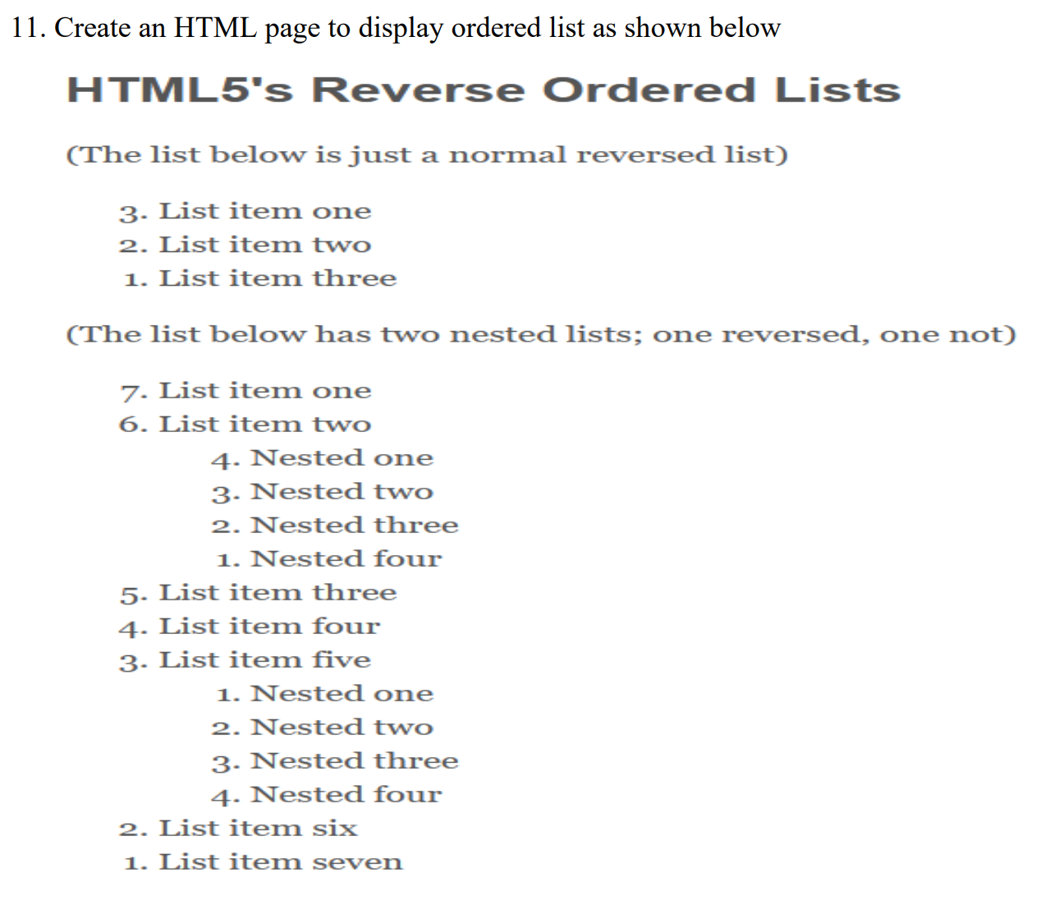

**HTML Code**

<!DOCTYPE html>

<html lang="en">

<head>

<meta charset="UTF-8">

<meta name="viewport" content="width=device-width, initial-scale=1.0">

<title>Rowspan & Colspan </title>

</head>

<body>

<h1>HTML5's Reverse Ordered Lists</h1>

<p>(This list below is just a normal reversed list)</p>

<ol type="1" reversed>

<li>List item one</li>

<li>List item two</li>

<li>List item three</li>

</ol>

<p>(This list below has two nested list; one reversed, one not)</p>

<ol type="1" reversed>

<li>List item one</li>

<li>List item two

<ol type="1" reversed>

<li>Nested one</li>

<li>Nested two</li>

<li>Nested three</li>

<li>Nested four</li>

</ol>

</li>

<li>List item three</li>

<li>List item four</li>

<li>List item five

<ol type="1">

<li>Nested one</li>

<li>Nested two</li>

<li>Nested Three</li>

<li>Nested Four</li>

</ol>

</li>

<li>List item six</li>

<li>List item seven</li>

</ol></body>

</html>

**Output**

**HTML Code**

<!DOCTYPE html>

<html lang="en">

<head>

<title>Table </title>

</head>

<body>

<table border="2">

<tr>

<th>Name</th>

<th>Image</th>

<th>Category</th>

</tr>

<tr>

<td><b><i>Sparrow</i></b></td>

<td><img src="/images /sparrow.jpg" height="50px" alt=""></td>

<td><b><i>Bird</i></b></td>

</tr>

<tr>

<td><b><i>Peacock</i></b></td>

<td><img src="/ images /peacock.jpg" height="50px" alt=""></td>

<td><b><i>Bird</i></b></td>

</tr>

<tr>

<td><b><i>Rabbit</i></b></td>

<td><img src="/ images /rabbit.jpg" height="50px" alt=""></td>

<td><b><i>Animal</i></b></td>

</tr>

<tr>

<td><b><i>Cat</i></b></td>

<td><img src="/ images /cat.jpg" height="50px" alt=""></td>

<td><b><i>Animal</i></b></td>

</tr>

</table>

</body>

</html>

**Output**

